

**SCSJ3253**

**PROGRAMMING TECHNIQUE III**

**REPORT FOR ASSIGNMENT 4**

**(WEB DESIGN)**

Prepare for:

**PM DR MOHD SHAHIZAN OTHMAN**

|  |  |  |
| --- | --- | --- |
| 1 | NEOH SIEW TENG | SX180532CSJS04 |
| 2 | RAMLI ABDUL RAHIM | SX161518CSJF04 |
| 3 | ROHAYA BINTI ABDUL KARIM | SX180608CSJS04 |
| 4 | NOR AMIRA BINTI AHMAD AZIZI | SX160105CSJS04 |

Home Page

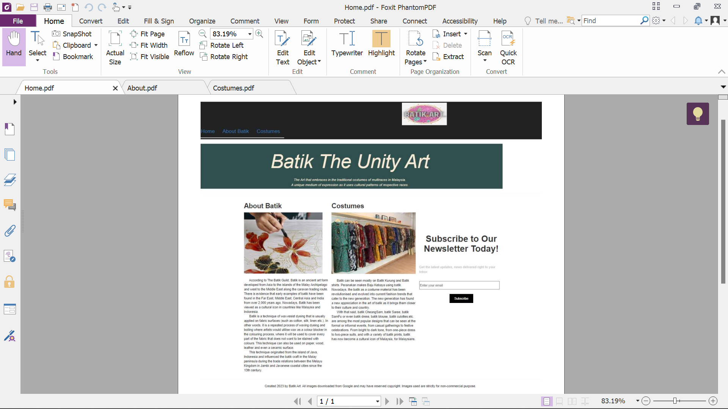

About

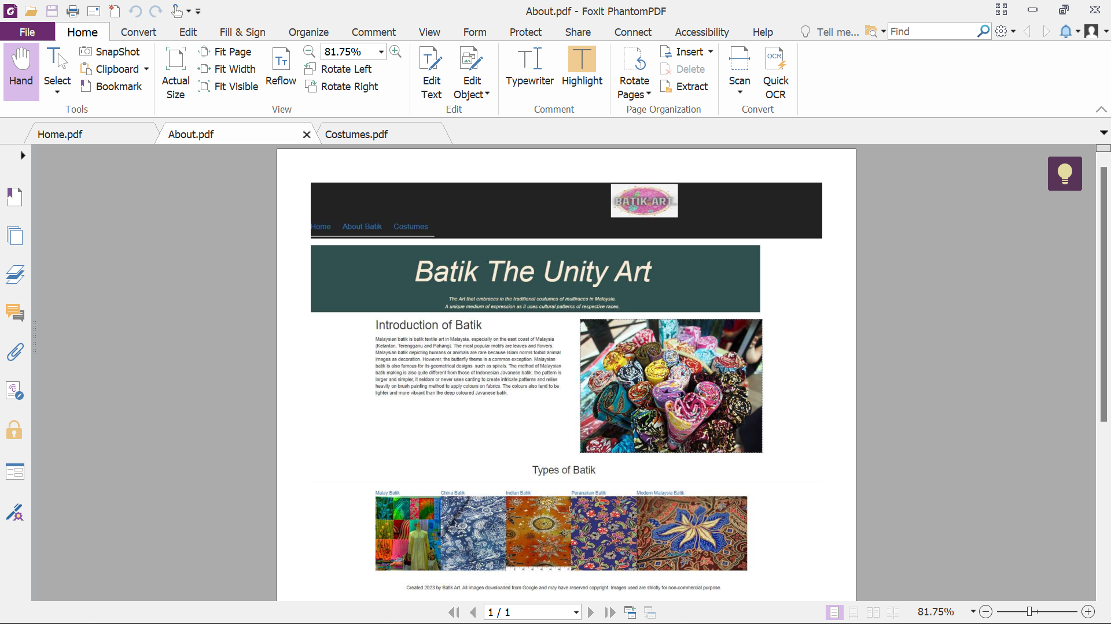

Costumes

